SCHOOL

Semester One Examination, 2013

Question/Answer Booklet

MATHEMATICS SPECIALIST 3C
SOLUTIONS

Section One:

Calculator-free

Student Number: In figures

In words

Your name

Time allowed for this section
Reading time before commencing work: five minutes
Working time for this section: fifty minutes

Materials required/recommended for this section

To be provided by the supervisor
This Question/Answer Booklet
Formula Sheet

To be provided by the candidate
Standard items: pens, pencils, pencil sharpener, eraser, correction fluid/tape, ruler, highlighters

Special items: nil

Important note to candidates

No other items may be used in this section of the examination. It is your responsibility to ensure that you do not have any unauthorised notes or other items of a non-personal nature in the examination room. If you have any unauthorised material with you, hand it to the supervisor before reading any further.

Structure of this paper

Section | Number of questions available | Number of questions to be answered | Working time (minutes) | Marks available | Percentage of exam
Section One:  Calculator-free | 7 | 7 | 50 | 50 | 33
Section Two:  Calculator-assumed | 12 | 12 | 100 | 100 | 67
 |  |  | Total | 150 | 100

Instructions to candidates

- The rules for the conduct of Western Australian external examinations are detailed in the Year 12 Information Handbook 2013. Sitting this examination implies that you agree to abide by these rules.

- Write your answers in the spaces provided in this Question/Answer Booklet. Spare pages are included at the end of this booklet. They can be used for planning your responses and/or as additional space if required to continue an answer.
- Planning: If you use the spare pages for planning, indicate this clearly at the top of the page.
- Continuing an answer: If you need to use the space to continue an answer, indicate in the original answer space where the answer is continued, i.e. give the page number. Fill in the number of the question(s) that you are continuing to answer at the top of the page.

- Show all your working clearly. Your working should be in sufficient detail to allow your answers to be checked readily and for marks to be awarded for reasoning. Incorrect answers given without supporting reasoning cannot be allocated any marks. For any question or part question worth more than two marks, valid working or justification is required to receive full marks. If you repeat an answer to any question, ensure that you cancel the answer you do not wish to have marked.

- It is recommended that you do not use pencil, except in diagrams.

Section One: Calculator-free (50 Marks)
This section has seven (7) questions. Answer all questions. Write your answers in the spaces provided.

Working time for this section is 50 minutes.

Question 1 (4 marks)
Prove by deduction that 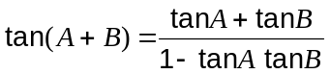.

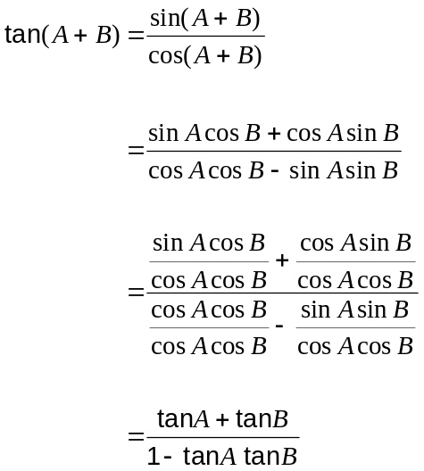

Question 2 (8 marks)
Two complex numbers are given by 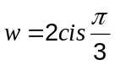 and 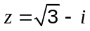.

(a) Express in polar form

(i) (1 mark)
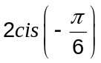

(ii) (1 mark)
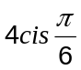

(b) State the

(i) argument of 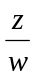 (1 mark)
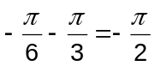

(ii) modulus of (1 mark)


(c) Show that the product 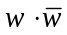 is purely real. (2 marks)
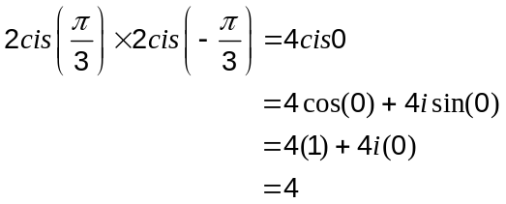

(d) For what positive values of is 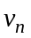 purely real, given 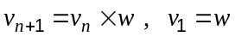?
(2 marks)
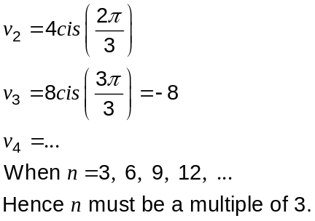

Question 3 (9 marks)
(a) Find 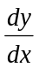 for the following:

(i) 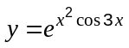 (2 marks)

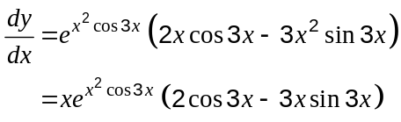

(ii) 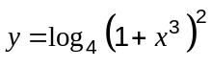 (2 marks)
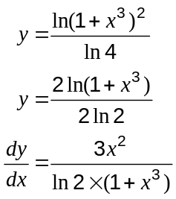

(b) Determine

(i) 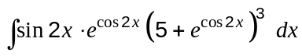 (3 marks)
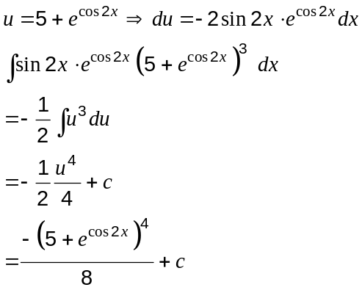

(ii) 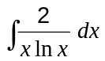 (2 marks)
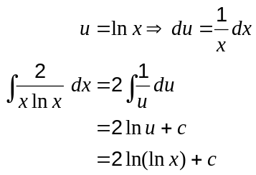
Question 4 (8 marks)
(a) Find the values of and when 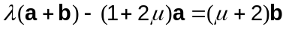, given that and are non-parallel vectors. (3 marks)

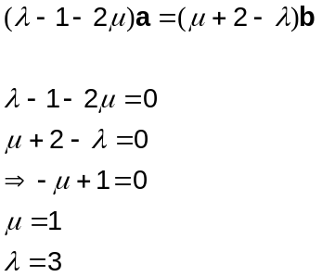

(b) P, Q and R are three collinear points with position vectors p, q and r respectively, where Q lies between P and R. If 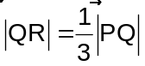, find r in terms of p and q. (2 marks)
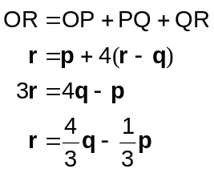

(c) Point C has position vector 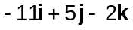 and point D has position vector . Find the position vector of the point P that divides  internally in the ratio 3:1. (3 marks)

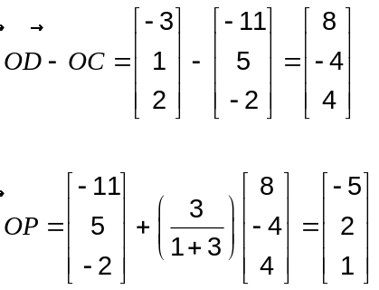

Question 5 (6 marks)
The graph of 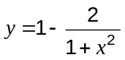 is shown for 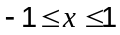.
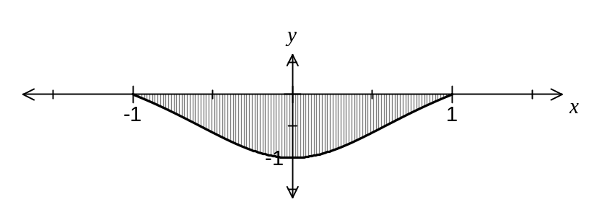
(a) Using the substitution 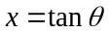 or otherwise, show that 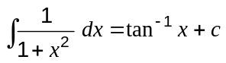. (4 marks)

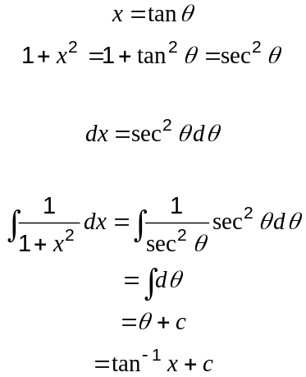

(b) Find the exact area of the shaded region above. (2 marks)
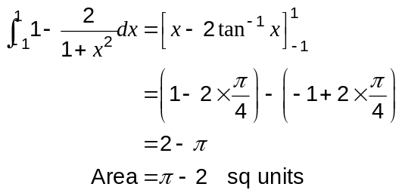

Question 6 (7 marks)
A function is defined as 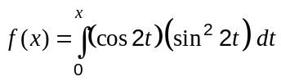 for 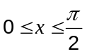.

(a) Determine the -coordinates of the stationary values of . (2 marks)
Require 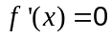

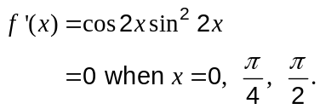

(b) Express in terms of only. (3 marks)
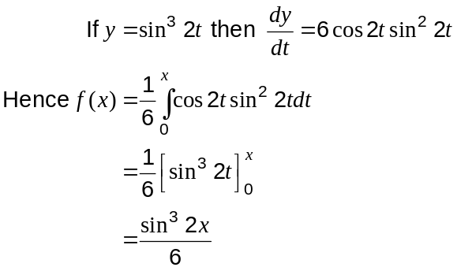

(c) Find the maximum value of . (2 marks)
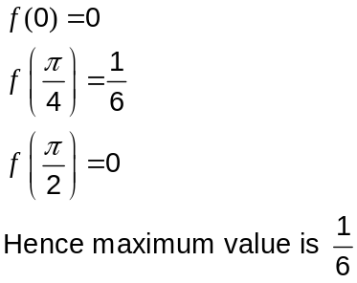
Question 7 (8 marks)
Two particles, A and B, are tracked in a laboratory experiment.

Particle A was observed to have initial position 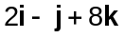cm and constant velocity vector cm/s.

Particle B was observed to have initial position 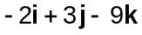cm and constant velocity vector 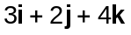cm/s.

If the particles continue with these velocities, find the minimum distance between them in the subsequent motion and the time when this occurs.

Let and be velocity and displacement of A relative to B

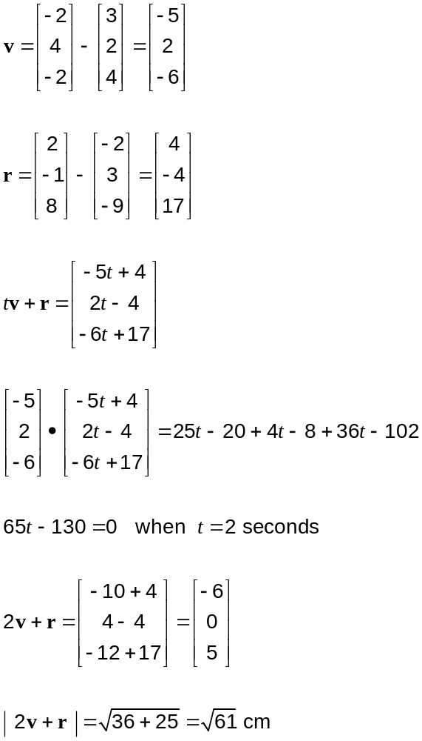

Additional working space

Question number: _________

Additional working space

Question number: _________

This examination paper may be freely copied, or communicated on an intranet, for non-commercial purposes within educational institutes that have purchased the paper from WA Examination Papers provided that WA Examination Papers is acknowledged as the copyright owner. Teachers within purchasing schools may change the paper provided that WA Examination Paper's moral rights are not infringed.

Copying or communication for any other purposes can only be done within the terms of the Copyright Act or with prior written permission of WA Examination papers.

Published by WA Examination Papers
PO Box 445 Claremont WA 6910

